1.
import numpy as np

student_scores = np.array([
[85, 90, 78, 88],
[75, 80, 85, 70],
[90, 95, 88, 92],
[80, 85, 90, 82]
])

avg = np.mean(student_scores, axis=0)

subjects = ["Math", "Science", "English", "History"]

print("Average marks:", avg)
print("Highest average subject:", subjects[np.argmax(avg)])

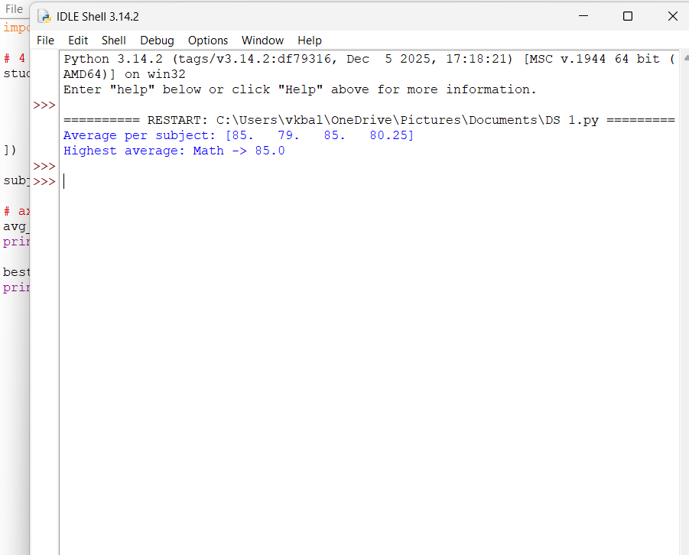

2.
import numpy as np

sales_data = np.array([
[100, 150, 200],
[120, 180, 240],
[90, 160, 210]
])

avg_price = np.mean(sales_data)

print("Average price:", avg_price)

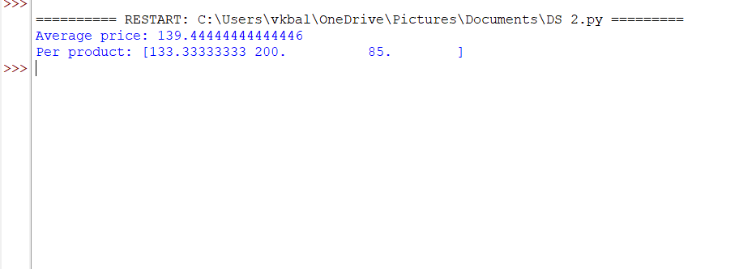

3.

import numpy as np

house_data = np.array([
[3, 1200, 250000],
[5, 1800, 400000],
[4, 1500, 300000],
[6, 2200, 500000],
[5, 2000, 450000]
])

filtered = house_data[house_data[:, 0] > 4]

avg_price = np.mean(filtered[:, 2])

print("Average sale price:", avg_price)
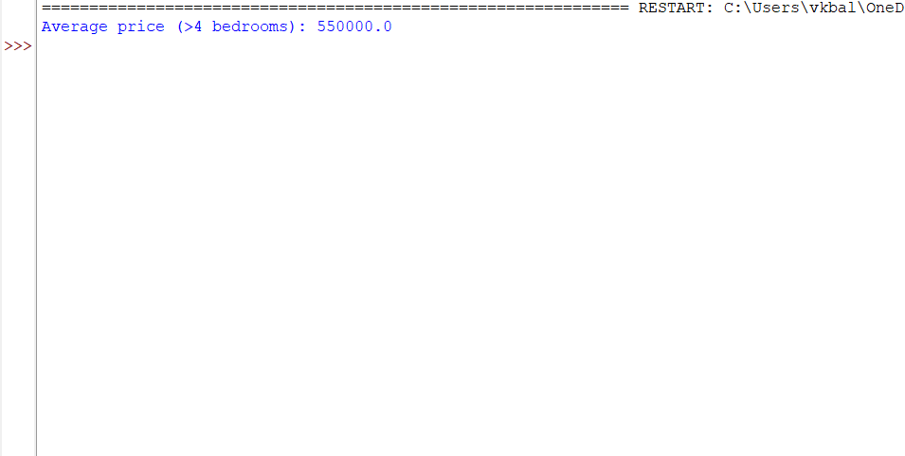

4.
import numpy as np

sales_data = np.array([10000, 12000, 15000, 18000])

total_sales = np.sum(sales_data)

increase = ((sales_data[3] - sales_data[0])
/ sales_data[0]) * 100

print("Total annual sales:", total_sales)
print("Percentage increase:", increase, "%")
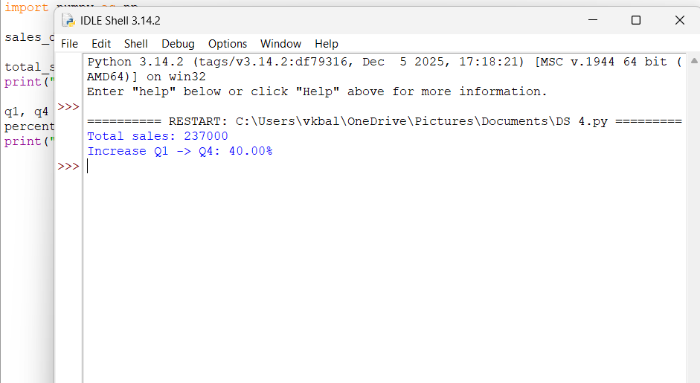

5.
import numpy as np

fuel_efficiency = np.array([25, 30, 35, 40, 45])

avg_efficiency = np.mean(fuel_efficiency)

car1 = fuel_efficiency[0]
car2 = fuel_efficiency[1]

improvement = ((car2 - car1) / car1) * 100

print("Average fuel efficiency:", avg_efficiency, "mpg")
print("Percentage improvement:", improvement, "%")
